**AIM:**

To draw the usecase diagram for the Evolutionary Algorithmic Gaming paradigm.

**SOFTWARE REQUIREMENTS**:

• JavaScript

**PROJECT DESCRIPTION:**

Applying Genetic Algorithm over simple JavaScript game to simulate the process of Machine Learning.

Rockets teach themselves on how to avoid obstacles and reach the destined target.

The Genetic Algorithm is inspired by Biological Counterparts of Reproduction, Mutation, Recombination and Selection.

A Fitness Function determines the quality of the solution. Evolution of the population then takes place after the repeated application of the above operators.

**USE CASE DIAGRAM:**

This diagram will contain the actors, use cases which are given below

**Actors**: Player.

**Use case**: Position of Target, Random Initial Rockets, Current Population, Distance of Rocket to Target, Fitness Function, Entity Selection,Crossover, Mutation.

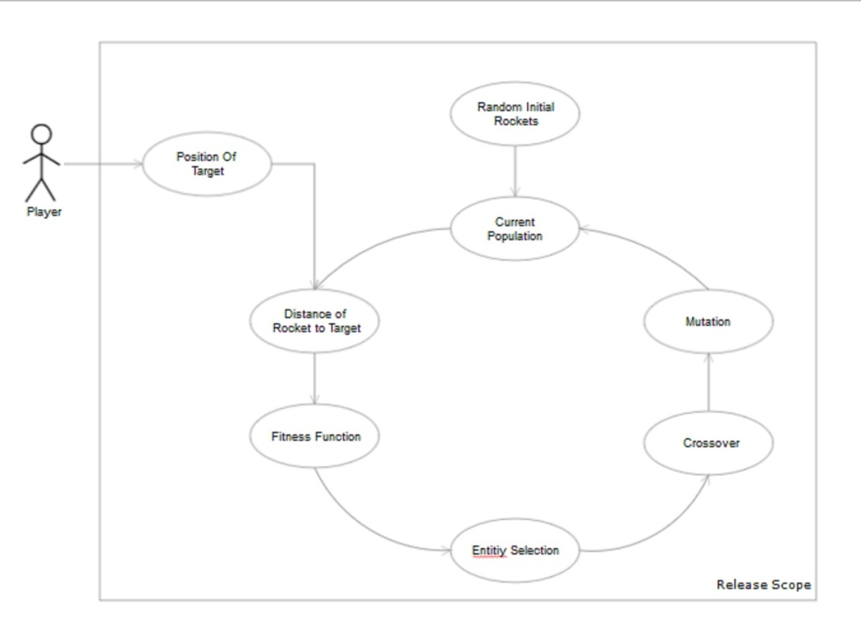

**RESULT:**

Thus the usecasediagram for the Evolutionary Algorithmic Gaming paradigm has been designed, executed and output is verified.